Assignment
- Generate code to fetch weather data securely without exposing API keys in the code.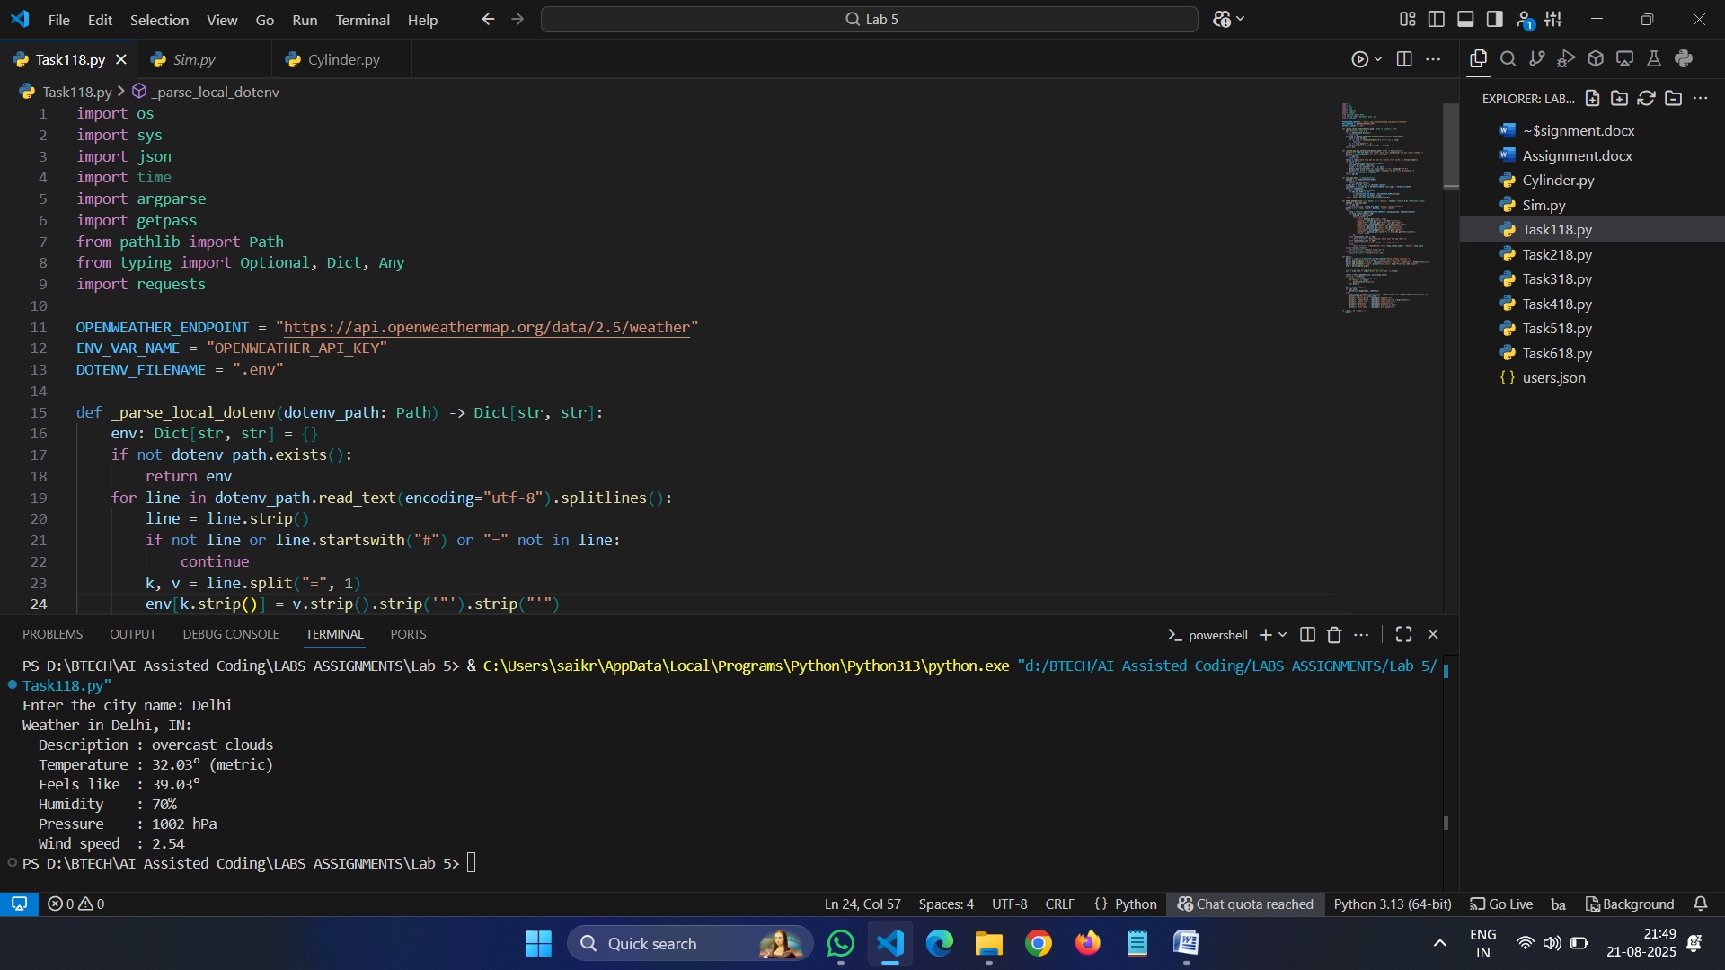
- Generate Python code for QuickSort and BubbleSort, and include comments explaining step-by-step how each works and where they differ.
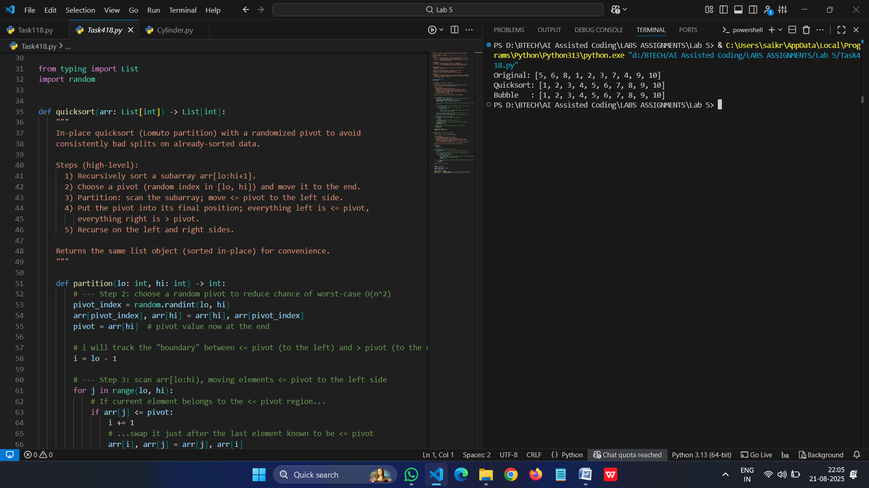
- Generate a recommendation system that also provides reasons for each suggestion

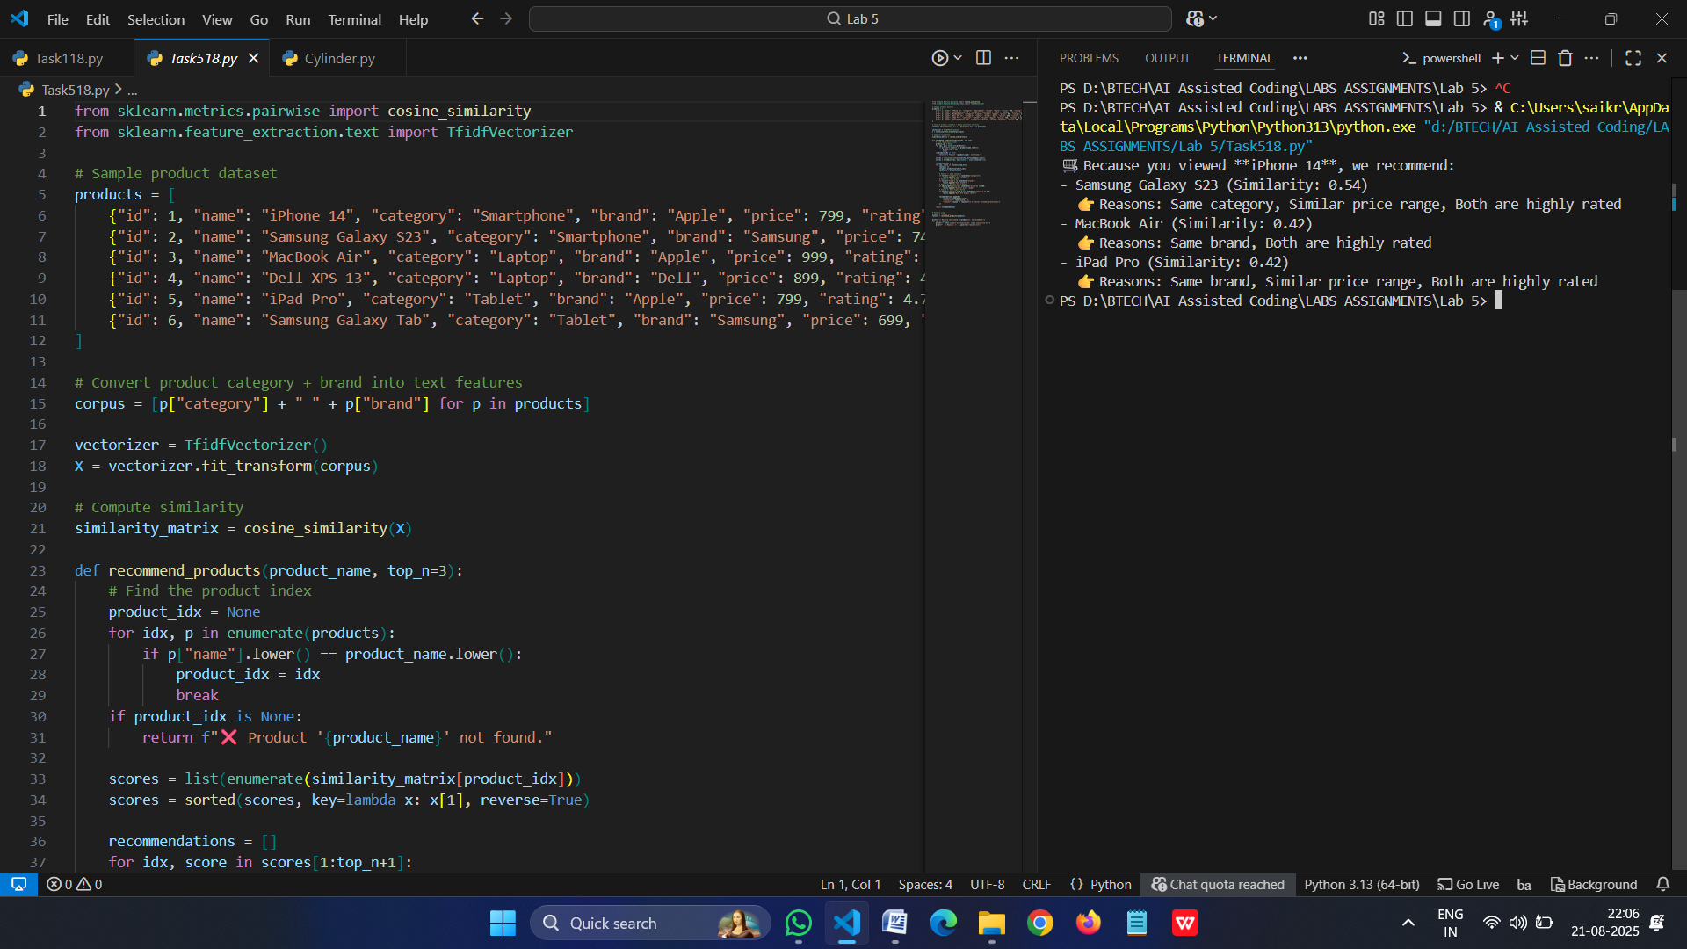

- Generate a recursive factorial function with comments that explain each line and a final summary of the algorithm’s flow

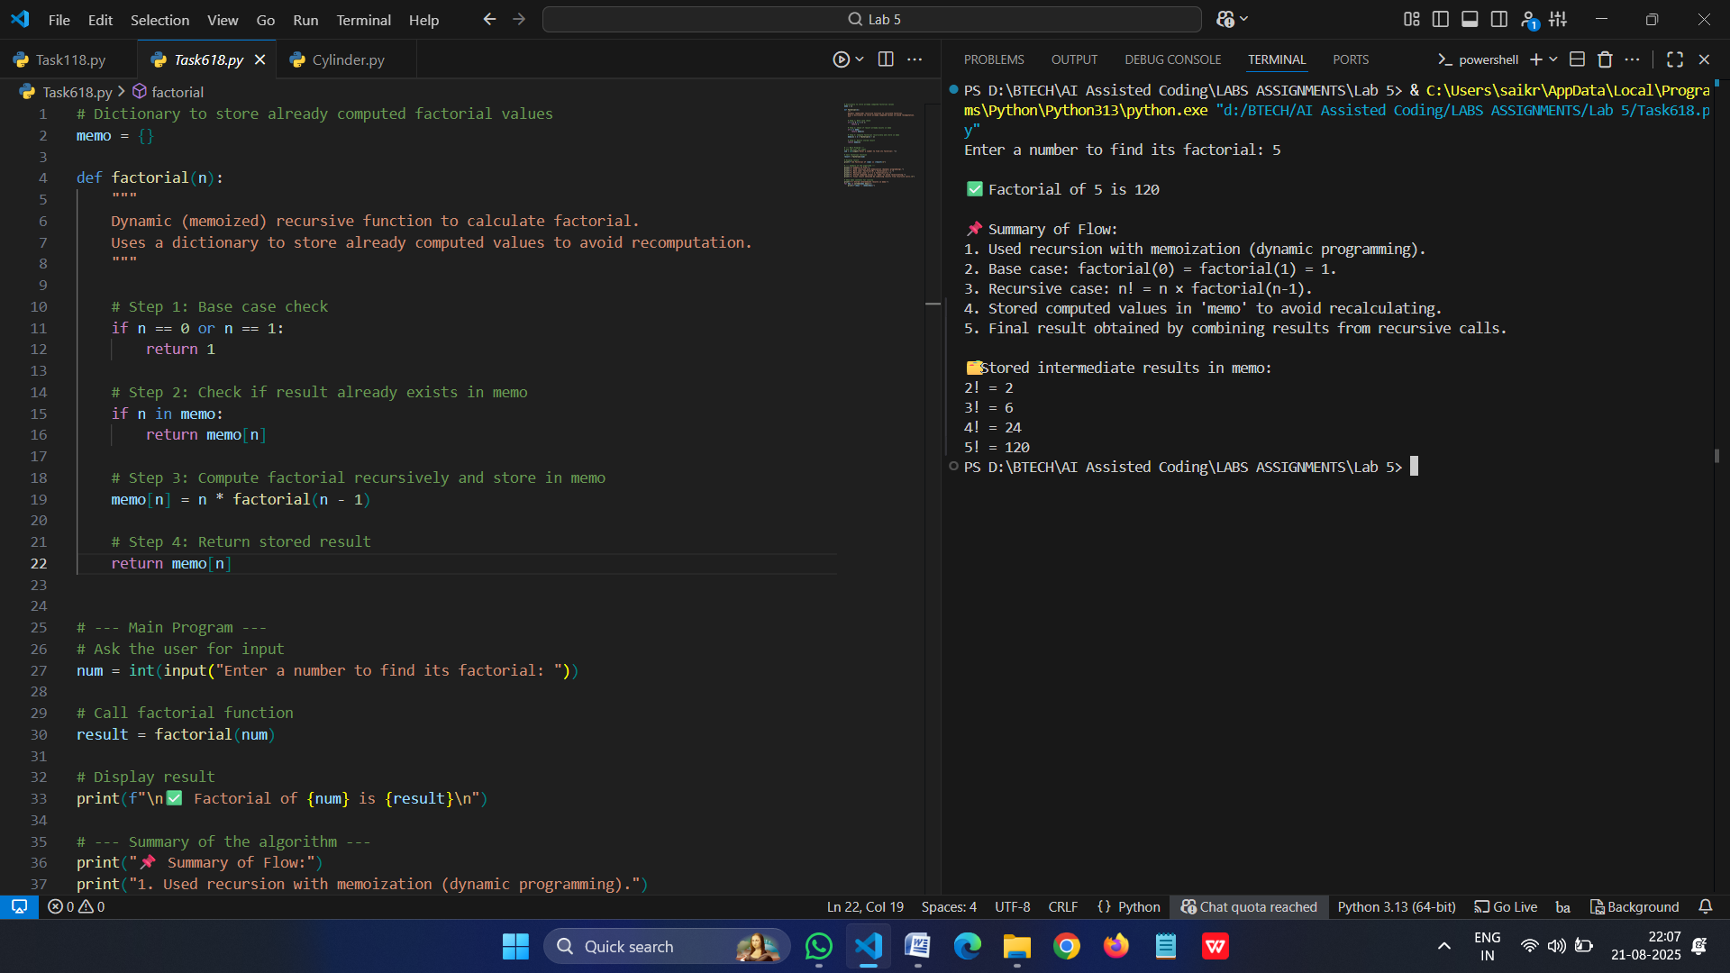
• Prompt GitHub Copilot to generate a Python script that collects user data (e.g., name, age, email). Then, ask Copilot to add comments on how to anonymize or protect this data.

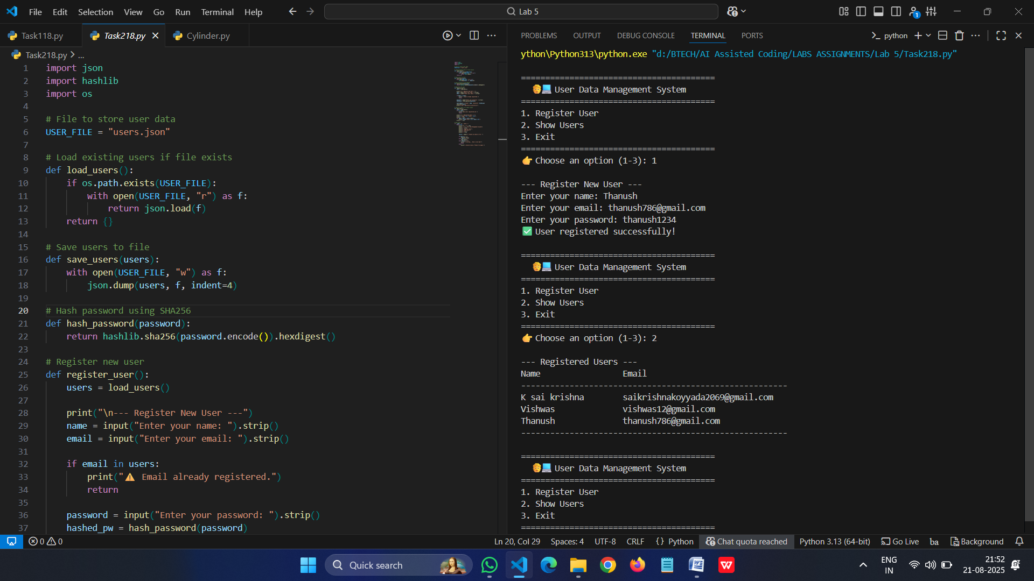

- Generate an Armstrong number checking function with comments and explanation.
